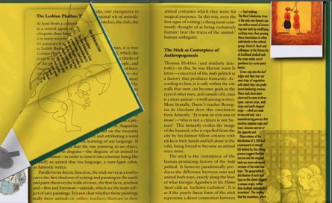In the publishing project, I chose to make an e-book. I learned how to effectively create digital interactions and content, which included re-editing clear and attractive texts, selecting appropriate images and designing interactive elements according to the content of the book, improving the artistic appreciation of the content to enhance the user experience. The simulated page-turning effect of the e-book was achieved, which added to the fun of reading. Through this project, I mastered the skills of using digital tools and platforms, such as document editing software and digital publishing tools, which are essential in the modern publishing industry.

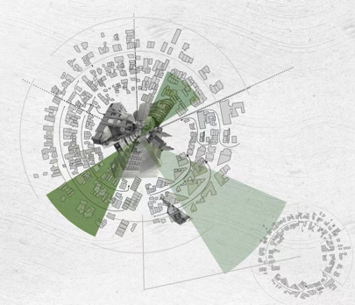In the project innovation map project, I learned how to collaborate and manage projects in a team environment. This includes team field research and collaborative collection of elements. This involves collaborating with team members to develop project plans, assign tasks and ensure that the project is completed on time. In the production, by browsing map cases and thinking, I broke the traditional way of presenting information on maps, made the map into a disc shape, and combined it with design aesthetics to make it a unique artistic image.

Through these projects, I deeply realized that digital content creation needs to comprehensively consider text content, user needs, and technical implementation. I realized that design and user experience are essential to attract readers and facilitate dissemination. In the Project Innovation Map project, I found that good teamwork and effective communication are the key factors for project success, not just technology or creativity.

Through these projects, I not only learned specific skills and knowledge, but also developed teamwork, communication and problem-solving skills. I have a deeper understanding of digital publishing production processes and project management, and I realize that innovation is not just the application of new technologies, but also includes rethinking problems and creative design of solutions.

In practice, I plan to apply what I have learned to my future work. I will actively participate in digital content creation projects and use project management skills to manage and promote project development. I also plan to continue to learn and explore new technologies and methods to continuously improve my capabilities and influence in the field of digital publishing and innovative project management.